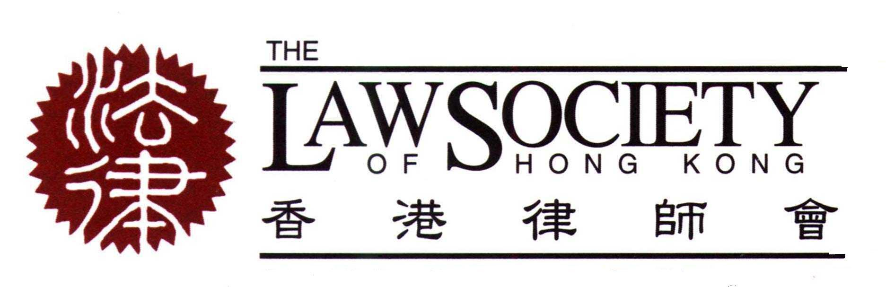
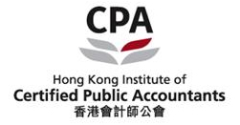
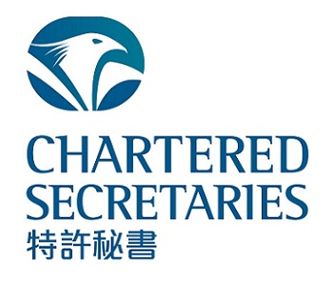

Supporting organisation Host Supporting organisation



Seminars on “Tax Planning in an Increasingly Transparent World” and  “Rethinking Independent Non-Executive Directorships”
  CPD point(s):
  The Law Society of Hong Kong | : 4 CPD points;  (2 points per session)
  The HKICPA | : 4 CPD hours;  (2 hours per session)
  The HKICS | : 4 CPD points;  (2 points per session)
Friday, 11 September 2015

Topic | Session 1 –  Tax Planning in an Increasingly Transparent World |  | Session 2 –  Rethinking Independent  Non-Executive Directorships
Time | 10:00 a.m. – 12:00 noon |  | 2:30 p.m. – 4:30 p.m.
Presenters | Mr. Scott D. Michel  Adjunct Professor of Law,  Graduate Program in Taxation,  University of Miami School of Law and Member of Caplin & Drysdale, United States  Mr. H. David Rosenbloom  Director of the International Tax Program, New York University School of Law and Member of Caplin & Drysdale, United States |  | Professor C. K. Low,  CUHK Business School,  The Chinese University of Hong Kong
Venue | : Joint Professional Centre, Unit 1, G/F, The Centre,  99 Queen’s Road Central, Hong Kong
Level | : Intermediate
Language | : English
Fee | : For members of the Law Society, HKICPA or HKICS  HK$450 for the full-day seminar or HK$250 per session  For non-members  HK$810 for the full-day seminar or HK$450 per session
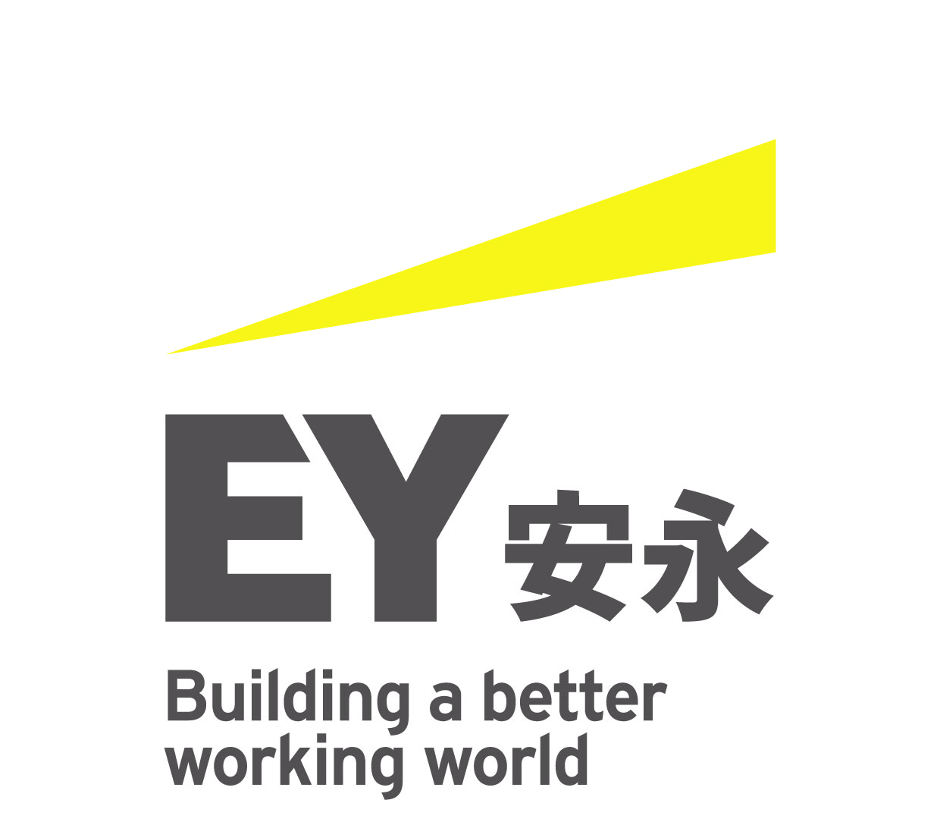
In association with: Sponsors:

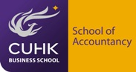



About the course
Session 1 - Tax Planning in an Increasingly Transparent World

The tax planner’s watchword that a taxpayer needs only pay the minimum taxes required by law is under increasing pressure with the mutation of the very nature of tax planning. Persons with a professional interest in taxation and entrusted with the task of providing advice need to be sensitized to this constantly shifting ground. Beginning in the last decade, tax authorities worldwide have begun to push the outer bounds of anti-abuse doctrines, even bringing criminal charges against tax planners thought to have crossed the line into conspiratorial conduct aimed at unlawfully reducing a taxpayer’s liability. Now, the combination of ethical, political and even ‘moral’ considerations, the news media, the possibility of leakers and whistleblowers, and even a heightened sense of ‘patriotism’ have put increasing pressure on the tax planning trade. This seminar will discuss how tax planners can perform their jobs appropriately in this increasingly pressurized environment.

Session 2 - Rethinking Independent Non-Executive Directorships

Academic studies are at best ambiguous in terms of the contributions that independent non-executive directors (‘INEDs’) make towards the performance of the companies on which board they serve and indeed of the quality of their monitoring of executive management. With this in mind, can one unequivocally say that the INED is truly independent and would be able to represent the interests of all the shareholders of the company? This seminar sets out a framework for rethinking the appointment and the role of INEDs within an environment which is dominated by controlling shareholders.
About the presenters
Session 1 - Tax Planning in an Increasingly Transparent World

Scott D. Michel is a Member of Caplin & Drysdale, Chartered and has been with the firm since 1981. He is on the firm’s Board of Directors and served as the firm’s President from 2007 to 2015. Mr. Michel advises clients on a wide range of tax compliance issues, including criminal tax investigations, sensitive civil audits, and voluntary disclosures. Currently he represents numerous clients worldwide in such matters arising from the IRS and Justice Department’s recent crackdown on unreported foreign assets and accounts, including a number of Swiss banks participating in the Department of Justice Swiss Bank Program announced in 2013. Mr. Michel speaks and writes frequently on tax enforcement issues, and has made presentations throughout the U.S., and in Seoul, Singapore, Hong Kong, Vienna, Zurich, Geneva, Mumbai, and Kuwait City to multiple law firms, bankers, and tax and financial advisors. He is also the co-chair of the American Bar Association Section of Taxation's Annual Conference on International Tax Enforcement, and has also appeared at other programs held by the American Bar Association, The Tax Executives Institute (U.S. and foreign branches), and the Virginia, New York University, Tennessee, and North Carolina Tax Institutes. Mr. Michel is also an Adjunct Professor of Law at the University of Miami School of Law Graduate Program in Taxation. He served as a Council Director for the American Bar Association’s Section of Taxation and previously chaired the Tax Section's Committees on Civil and Criminal Tax Penalties and on Standards of Tax Practice. Mr. Michel graduated from Northwestern University in 1977 with highest distinction and in 1980 from the University of Virginia School of Law as a member of the Order of Coif. From 1980 to 1981, he served as clerk to the Honorable Joyce Hens Green, U.S. District Court for the District of Columbia.

H. David Rosenbloom is the Director of the International Tax Program at New York University School of Law and a member of Caplin & Drysdale, Chartered, a law firm he rejoined in 1981 after serving as International Tax Counsel and Director, Office of International Tax Affairs, in the U.S. Treasury Department from 1978 to 1981. Born in 1941, Mr. Rosenbloom graduated from Princeton University summa cum laude in 1962 and, after a year as a Fulbright Scholar at the University of Florence in Florence, Italy, attended Harvard Law School. He graduated magna cum laude in 1966 and was President of Volume 79 of the Harvard Law Review. Mr. Rosenbloom served as assistant to Ambassador Arthur Goldberg at the U.S. Mission to the United Nations and then as clerk to U.S. Supreme Court Justice Abe Fortas. A frequent speaker and author on tax subjects, Mr. Rosenbloom has taught international taxation and related subjects at Stanford, Columbia, the University of Pennsylvania, Harvard, and New York University Law Schools, and at educational institutions in Taipei, Mexico City, Milan, Bergamo, Sydney, Mainz, Heidelberg, Rio de Janeiro, Pretoria, Melbourne, Vienna, Lisbon, Leiden, and Neuchâtel. He has also served as Tax Policy Advisor for the U.S. Treasury, the OECD, AID, and the World Bank in Eastern Europe, the Former Soviet Union, Senegal, Malawi, and South Africa. In recent years he has served as an expert witness on international tax matters in the United States, New Zealand, Canada, Australia, the Netherlands, and Norway.

Session 2 - Rethinking Independent Non-Executive Directorships

Professor C K Low is an Associate Professor in Corporate Law at CUHK Business School with research interests in issues pertaining to corporate governance and the regulatory framework of capital markets. His research, which has published in journals in Australasia, Europe and the United States of America, is supported by private sector grants from Ernst & Young, Noble Group, Sino Group and Tricor Group. An Advocate and Solicitor of the High Court of Malaya, CK is a member of the Process Review Panel of the Financial Reporting Council and the Securities and Futures Appeals Tribunal in Hong Kong. He was a member of the Listing Committee of the Stock Exchange of Hong Kong from May 2006 to July 2010 and served on the board of directors of the Asian Institute of Finance in Malaysia for three years through April 2012.

Supporting organization Host Supporting organisation

Seminars on
Session 1 - “Tax Planning in an Increasingly Transparent World” and
Session 2 - “Rethinking Independent Non-Executive Directorships”

11 September 2015

Enrolment Slip

To : The Law Society of Hong Kong, 3rd Floor, Wing On House, 71 Des Voeux Road Central, Hong Kong
(Attention: Ms. Goldie Ng / Ms. Hailey Luk - Tel: 2846 0585 / 2846 0587)

Name: Mr./Ms.
(full name)

I would like to enrol in

Full Day Seminar (HK$450 for members / HK$810 for non-members); or
Session 1 from 10:00 a.m. to 12:00 noon (HK$250 for members / HK$450 for non-members); or
Session 2 from 2:30 p.m. to 4:30 p.m. (HK$250 for members / HK$450 for non-members)
(please tick as appropriate)

I am a:
Law Society Member
Solicitor No : (if applicable)
Year of admission: (if applicable)
Trainee : First / Second year (if applicable)

HKICPA Member (membership number : )
HKICS Member (membership number : )
Non-member (please specify your occupation : )
(please tick as appropriate)

Do you wish to claim CPD points for your attendance?
CPD points required from The Law Society of Hong Kong
CPD points required from the HKICPA
CPD points required from the HKICS
(please tick as appropriate)

Company/Firm: Fax:

Address:

E-mail: Tel:

I enclose a cheque made payable to “The Law Society of Hong Kong” for $ in payment for the above course.

I have read and accepted the Enrolment Conditions as stated below.

Signature: Date:

Enrolment Conditions:
1. Enrolments will be accepted on a first-come-first-served basis.
2. The CPD Attendance Policy will apply to the Law Society’s members. Bad Weather Policy will apply to all participants. Please enquire for further details.
3. The Law Society of Hong Kong reserves the right to alter the contents, speakers(s) or otherwise of this course, or cancel this course.
4. Places cannot be reserved by facsimile. Registrations will only be accepted upon full payment of the course fee and receipt of the enrolment slip.
5. Course fees shall under no circumstances be refunded. If you cannot attend a booked course, you may transfer your booking to a replacement delegate provided that the Law Society is notified in writing at least one clear day in advance of the scheduled course date.

