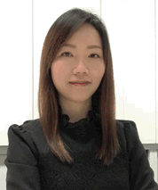  
**FANCL**資深營養師**Toby Leung**

**FANCL Senior Nutritionist Toby Leung**

* 香港中文大學食品營養與科技碩士

Master of Science in Nutrition, Food Science and Technology

* 擔任營養補充品專業培訓導師逾10年

Solid 10+ years of health supplement training experiences

* 曾於香港專業教育學院教授營養學高級文憑課程

Performed teaching duties for higher diploma courses in tertiary education institute

* 超過10年編寫營養餐單經驗，協助不同人士管理健康及體重

Provided individual nutritional consultation and meal planning services over 10 years

* 曾撰寫報章營養專欄及主講過百場健康講座

Organized over 100 health talks, public seminars, cooking programs, and wrote nutrition articles for local popular media