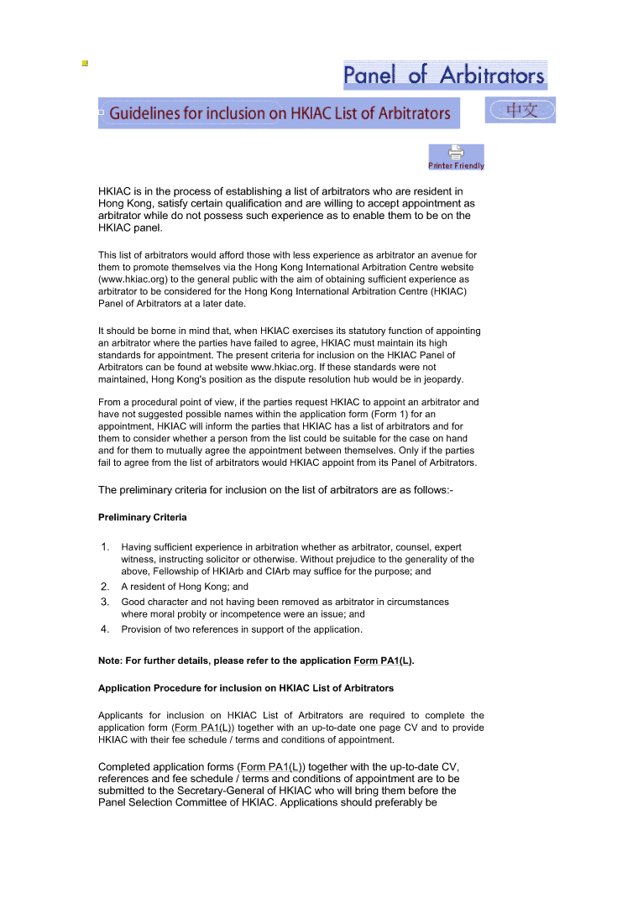
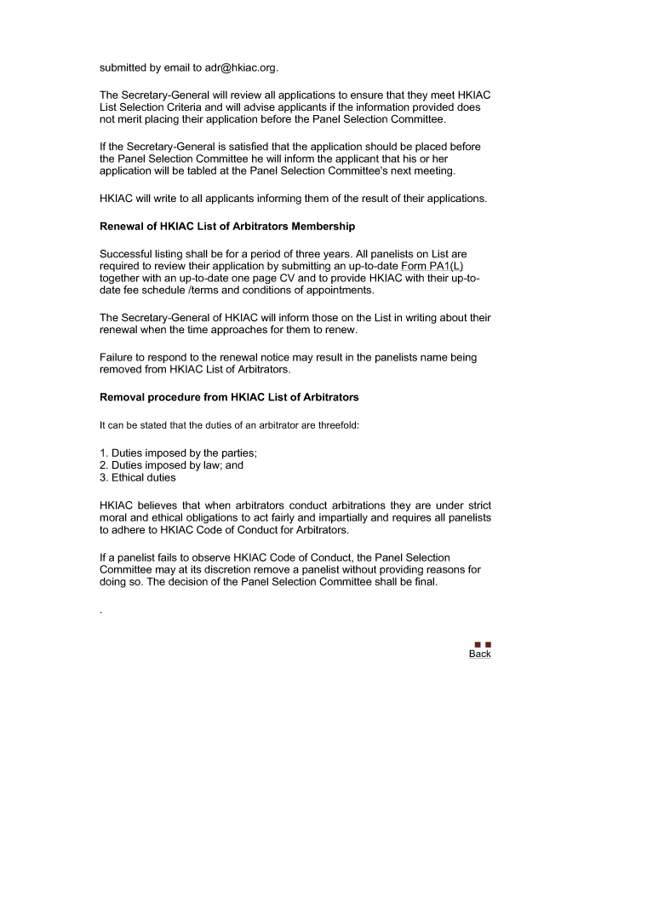

R E P L Y S L I P
(please return to HKIAC once completed)

I ____________________________ hereby authorize / do not authorize* HKIAC to disclose details of my CV to those who enquire into my services as arbitrator. I also authorize / do not authorize* HKIAC to include details of my CV on HKIAC’s website for general viewing by the public.

* delete as appropriate

I enclose the following completed documentation for HKIAC records:-

(a) Application form (Form PA1(L));
(b) CV;
(c) Two references in support of the application;
(d) Fee schedules / terms and conditions of appointment.

I have reviewed the Guidelines for listing and will adhere to the criteria accordingly.

Signed _____________________________ Date _______________________

